Xi'an Wanlai Trading Co., Ltd.
Serial Number | Product Name | Model number (diameter/depth/cm) | Weight (KG) | Material | Features | Product Image
Z-001 | Cast iron ingot pot | 20cm*7cm / 25cm*8.5cm  27cm*9cm / 30cm*9cm  32cm*9.5cm / 34cm*10cm  36cm*10cm / 38cm*12cm | 1.5 | cast iron | Uncoated  Gas stove  induction cooker  Both are available | 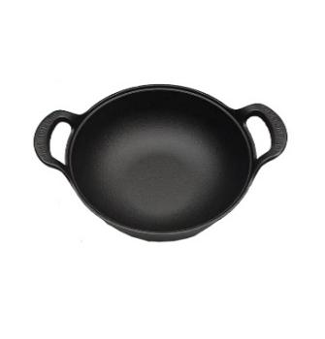
Z-001 | Cast iron ingot pot |  | 2.1 | cast iron | Uncoated  Gas stove  induction cooker  Both are available
Z-001 | Cast iron ingot pot |  | 2.4 | cast iron | Uncoated  Gas stove  induction cooker  Both are available
Z-001 | Cast iron ingot pot |  | 2.9 | cast iron | Uncoated  Gas stove  induction cooker  Both are available
Z-001 | Cast iron ingot pot |  | 3.4 | cast iron | Uncoated  Gas stove  induction cooker  Both are available
Z-001 | Cast iron ingot pot |  | 3.8 | cast iron | Uncoated  Gas stove  induction cooker  Both are available
Z-001 | Cast iron ingot pot |  | 4.2 | cast iron | Uncoated  Gas stove  induction cooker  Both are available
Z-001 | Cast iron ingot pot |  | 4.9 | cast iron | Uncoated  Gas stove  induction cooker  Both are available
Z-002 | Wooden handle flat-bottomed wok | 23cm*4cm / 25cm*5cm  27cm*5cm/29cm/5cm  The wooden handle is 20cm long. | 1.5 | cast iron | Uncoated  Gas stove  induction cooker | 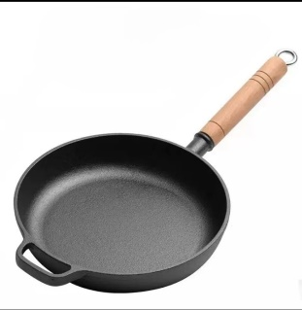
Z-002 | Wooden handle flat-bottomed wok |  | 1.8 | cast iron | Uncoated  Gas stove  induction cooker
Z-002 | Wooden handle flat-bottomed wok |  | 2.1 | cast iron | Uncoated  Gas stove  induction cooker
Z-002 | Wooden handle flat-bottomed wok |  | 2.4 | cast iron | Uncoated  Gas stove  induction cooker
Z003 | Shallow dish with rim | 28cm*2cm / 30cm*2cm  33cm*2.5cm / 35cm*2.5cm  37cm*2.5cm / 42cm*2.5cm | 1.6 | cast iron | Uncoated  Gas stove  induction cooker | 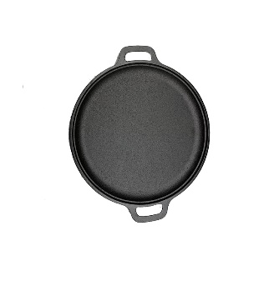
Z003 | Shallow dish with rim |  | 1.9 | cast iron | Uncoated  Gas stove  induction cooker
Z003 | Shallow dish with rim |  | 2.2 | cast iron | Uncoated  Gas stove  induction cooker
Z003 | Shallow dish with rim |  | 2.4 | cast iron | Uncoated  Gas stove  induction cooker
Z003 | Shallow dish with rim |  | 2.7 | cast iron | Uncoated  Gas stove  induction cooker
Z003 | Shallow dish with rim |  | 3.1 | cast iron | Uncoated  Gas stove  induction cooker
Z-005 | Outdoor round baking pan | 33cm*3.5cm | 3.5 | cast iron | Uncoated  Gas stove  induction cooker | 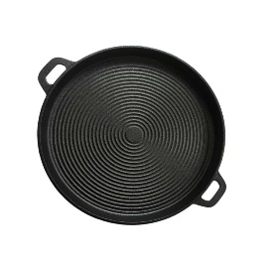
Xi'an Wanlai Trading Co., Ltd.
Serial Number | Product Name | Model (diameter/depth) cm | weight  KG | Material | Features | Product Image
Z-006 | Concave spiral roasting pan | 28cm in diameter / 30cm in diameter  32cm in diameter / 35cm in diameter | 1.7 | cast iron | Uncoated  Gas stove  induction cooker | 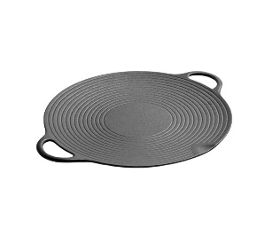
Z-006 | Concave spiral roasting pan |  | 1.9 | cast iron | Uncoated  Gas stove  induction cooker
Z-006 | Concave spiral roasting pan |  | 2.2 | cast iron | Uncoated  Gas stove  induction cooker
Z-006 | Concave spiral roasting pan |  | 2.7 | cast iron | Uncoated  Gas stove  induction cooker
Z-007 | Wooden handle flat frying pan | 20cm*2cm  23cm*2cm  26cm*2cm | 0.9 | cast iron | Uncoated  Gas stove  induction cooker | 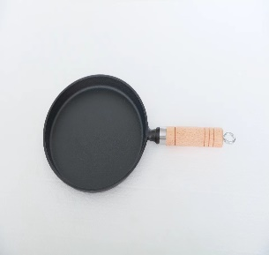
Z-007 | Wooden handle flat frying pan | 20cm*2cm  23cm*2cm  26cm*2cm | 1.2 | cast iron | Uncoated  Gas stove  induction cooker
Z-007 | Wooden handle flat frying pan | 20cm*2cm  23cm*2cm  26cm*2cm | 1.5 | cast iron | Uncoated  Gas stove  induction cooker
Z-008 | Iron-handled frying pan | 14cm*2cm  16cm*3.5/20cm*4cm  26cm*5cm | 0.5 | cast iron | Uncoated  Gas stove  induction cooker | 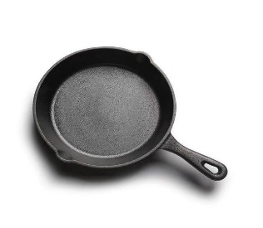
Z-008 | Iron-handled frying pan | 14cm*2cm  16cm*3.5/20cm*4cm  26cm*5cm | 0.7 | cast iron | Uncoated  Gas stove  induction cooker
Z-008 | Iron-handled frying pan | 14cm*2cm  16cm*3.5/20cm*4cm  26cm*5cm | 1.4 | cast iron | Uncoated  Gas stove  induction cooker
Z-008 | Iron-handled frying pan | 14cm*2cm  16cm*3.5/20cm*4cm  26cm*5cm | 1.9 | cast iron | Uncoated  Gas stove  induction cooker
Z-009 | Korean concave frying pan | 28cm  30cm  33ccm/37cm | 1.8 | cast iron | Uncoated  Gas stove  induction cooker | 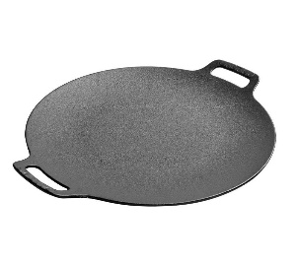
Z-009 | Korean concave frying pan | 28cm  30cm  33ccm/37cm | 2.0 | cast iron | Uncoated  Gas stove  induction cooker
Z-009 | Korean concave frying pan | 28cm  30cm  33ccm/37cm | 2.5 | cast iron | Uncoated  Gas stove  induction cooker
Z-009 | Korean concave frying pan | 28cm  30cm  33ccm/37cm | 3.1 | cast iron | Uncoated  Gas stove  induction cooker
Z-010 | Flatbread griddle | 26cm/28cmc/30ccm  32cm/34cm  37ccm/40cmc | 1.3 | cast iron | Uncoated  Gas stove  induction cooker | 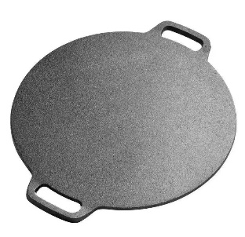
Z-010 | Flatbread griddle | 26cm/28cmc/30ccm  32cm/34cm  37ccm/40cmc | 1.6 | cast iron | Uncoated  Gas stove  induction cooker
Z-010 | Flatbread griddle | 26cm/28cmc/30ccm  32cm/34cm  37ccm/40cmc | 2.0 | cast iron | Uncoated  Gas stove  induction cooker
Z-010 | Flatbread griddle | 26cm/28cmc/30ccm  32cm/34cm  37ccm/40cmc | 2.4 | cast iron | Uncoated  Gas stove  induction cooker
Z-010 | Flatbread griddle | 26cm/28cmc/30ccm  32cm/34cm  37ccm/40cmc | 2.7 | cast iron | Uncoated  Gas stove  induction cooker
Z-010 | Flatbread griddle | 26cm/28cmc/30ccm  32cm/34cm  37ccm/40cmc | 3.5 | cast iron | Uncoated  Gas stove  induction cooker
Z-010 | Flatbread griddle | 26cm/28cmc/30ccm  32cm/34cm  37ccm/40cmc | 3.8 | cast iron | Uncoated  Gas stove  induction cooker
Xi'an Wanlai Trading Co., Ltd.
Serial Number | Product Name | Model (diameter/depth) cm | weight  KG | Material | Features | Product Image
Z-011 | Teppanyaki Steak | 20cm*2cm/  22cm*2cm / 24cm*2.5cm  26cm*2.5cm | 0.7 | cast iron | Uncoated  Gas stove  induction cooker | 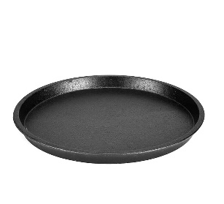
Z-011 | Teppanyaki Steak | 20cm*2cm/  22cm*2cm / 24cm*2.5cm  26cm*2.5cm | 0.9 | cast iron | Uncoated  Gas stove  induction cooker
Z-011 | Teppanyaki Steak | 20cm*2cm/  22cm*2cm / 24cm*2.5cm  26cm*2.5cm | 1.2 | cast iron | Uncoated  Gas stove  induction cooker
Z-011 | Teppanyaki Steak | 20cm*2cm/  22cm*2cm / 24cm*2.5cm  26cm*2.5cm | 1.4 | cast iron | Uncoated  Gas stove  induction cooker
Z-012 | Iron Handle Folding Pan | Small size: outer diameter 20cm * inner diameter 15cm  Medium size: outer diameter 25cm * inner diameter 19cm  Large size: outer diameter 28cm * inner diameter 23cm | 1.8 | cast iron | Uncoated  Gas stove | 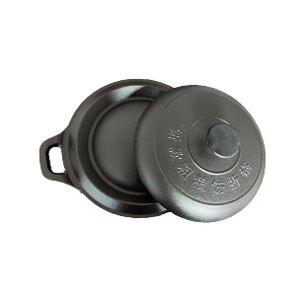
Z-012 | Iron Handle Folding Pan |  | 3.0 | cast iron | Uncoated  Gas stove
Z-012 | Iron Handle Folding Pan |  | 3.2 | cast iron | Uncoated  Gas stove
Z-013 | Old-fashioned stew pot | 20cm*9cm  22cm*10cm  24cm*10cmc / 26cm*11cm |  | cast iron | Uncoated  Gas stove  induction cooker | 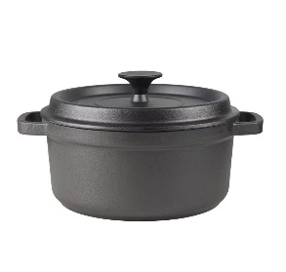
Z-013 | Old-fashioned stew pot | 20cm*9cm  22cm*10cm  24cm*10cmc / 26cm*11cm | 3.0 | cast iron | Uncoated  Gas stove  induction cooker
Z-013 | Old-fashioned stew pot | 20cm*9cm  22cm*10cm  24cm*10cmc / 26cm*11cm | 3.8 | cast iron | Uncoated  Gas stove  induction cooker
Z-013 | Old-fashioned stew pot | 20cm*9cm  22cm*10cm  24cm*10cmc / 26cm*11cm | 4.5 | cast iron | Uncoated  Gas stove  induction cooker
Z-013 | Old-fashioned stew pot | 20cm*9cm  22cm*10cm  24cm*10cmc / 26cm*11cm | 5.8 | cast iron | Uncoated  Gas stove  induction cooker
Z-014 | Wooden Handle Folding Pancake Pot | Outer diameter 26cm * Inner diameter 21cm  Outer diameter 28cm * inner diameter 23cm |  | cast iron | Uncoated  Gas stove | 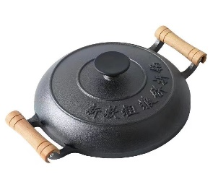
Z-014 | Wooden Handle Folding Pancake Pot |  | 2.5 | cast iron | Uncoated  Gas stove
Z-014 | Wooden Handle Folding Pancake Pot |  | 3.3 | cast iron | Uncoated  Gas stove
Z-015 | Four-hole egg cooker | 17cm*17cm*2cm  19cm*19cmc*2cm  Single hole diameter 8cm | 0.8 | cast iron | Uncoated  Gas stove  induction cooker | 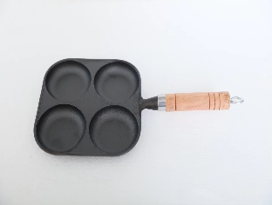
Z-015 | Four-hole egg cooker | 17cm*17cm*2cm  19cm*19cmc*2cm  Single hole diameter 8cm | 1.1 | cast iron | Uncoated  Gas stove  induction cooker

Xi'an Wanlai Trading Co., Ltd.
Serial Number | Product Name | Model (diameter/depth) cm | weight  KG | Material | Features | Product Image
Z-016 | Lace-edged four-hole egg fryer | 17.5cm*17.5cm*2cm  Single hole diameter 8.5cm | 0.8 | cast iron | Uncoated  Gas stove  induction cooker | 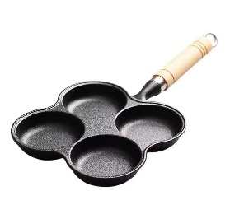
Z-017 | Egg fryer with a secondary handle | 17cm*17cm*2cm  20cm*20cm*2.5cm  Single hole diameter 8.5cm | 0.9 | cast iron | Uncoated  Gas stove  induction cooker | 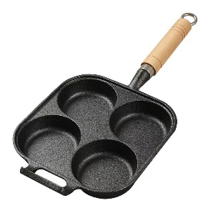
Z-017 | Egg fryer with a secondary handle | 17cm*17cm*2cm  20cm*20cm*2.5cm  Single hole diameter 8.5cm | 1.2 | cast iron | Uncoated  Gas stove  induction cooker
Z-018 | Diagonal four-hole egg fryer | 20cm*20cm*2.5cm  Single hole diameter 9cm | 1.3 | cast iron | Uncoated  Gas stove  induction cooker | 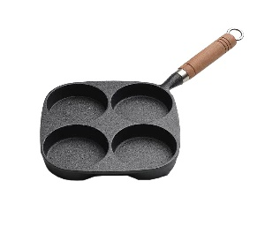
Z-019 | Three-hole egg cooker | Single aperture 8.5cm*2cm | 0.7 | cast iron | Uncoated  Gas stove  induction cooker | 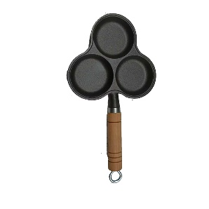

Xi'an Wanlai Trading Co., Ltd.
Serial Number | Product Name | Model (diameter/depth) cm | weight  KG | Material | Features | Product Image
Z-020 | Wooden handle steak pan  Single nozzle | 17cm*17cm*2.5cm  19cm*19cm*2.5cm | 1.0 | cast iron | Uncoated  Gas stove  induction cooker | 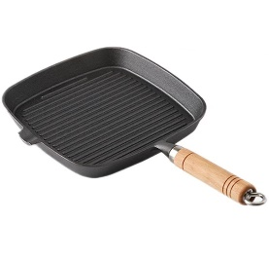
Z-020 | Wooden handle steak pan  Single nozzle | 17cm*17cm*2.5cm  19cm*19cm*2.5cm | 1.2 | cast iron | Uncoated  Gas stove  induction cooker
Z-021 | Wooden handle steak pan  Double oil nozzle | 17cm*17cm*2.5cm  19cm*19cm*2.5cm  21 cm * 21 cm * 3 cm | 1.0 | cast iron | Uncoated  Gas stove  induction cooker | 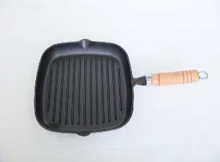
Z-021 | Wooden handle steak pan  Double oil nozzle | 17cm*17cm*2.5cm  19cm*19cm*2.5cm  21 cm * 21 cm * 3 cm | 1.2 | cast iron | Uncoated  Gas stove  induction cooker
Z-021 | Wooden handle steak pan  Double oil nozzle | 17cm*17cm*2.5cm  19cm*19cm*2.5cm  21 cm * 21 cm * 3 cm | 1.4 | cast iron | Uncoated  Gas stove  induction cooker
Z-022 | Single-handled oval striped frying pan | 23.5cm*17.5cm*2cm  Total length 37.5cm | 1.2 | cast iron | Uncoated  Gas stove  induction cooker | 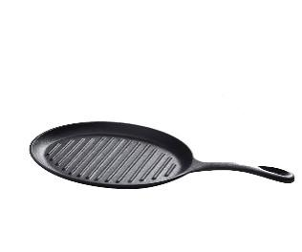
Z-023 | New steak griddle | 26cm*26cmc*4.5cm  The iron handle is 13.5cm long.  Total length 43cm | 2.35 | cast iron | Uncoated  Gas stove  induction cooker | 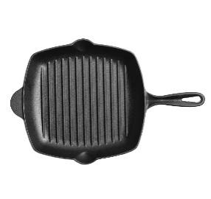
Z-024 | Square striped barbecue pan  Double oil nozzle | 26cm*26cm*4.5cm | 4.5 | cast iron | Uncoated  Gas stove  induction cooker | 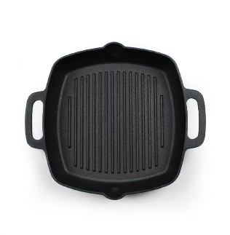
Xi'an Wanlai Trading Co., Ltd.
Serial Number | Product Name | Model (diameter/depth) cm | weight  KG | Material | Features | Product Image
Z-025 | Outdoor Iron Double-Handled Korean BBQ Platter | 30cm*25cm*2.5cm | 3.5 | cast iron | Uncoated  Gas stove  induction cooker | 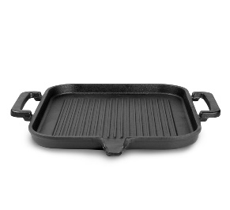
Z-026 | 3-in-1 Sausage Griller | 18.5cm*18.5cm*2.3cm  17cm long | 0.8 | cast iron | Uncoated  Gas stove  induction cooker | 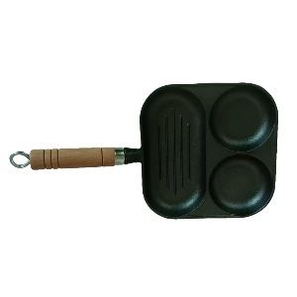
Z-027 | Horizontal sausage grill | 19.5cm*14cmc*2cm  The total length of the handle is 17cm. | 0.75 | cast iron | Uncoated  Gas stove  induction cooker | 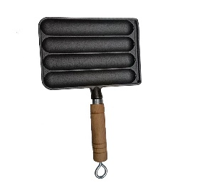
Z-028 | Vertical sausage grill | 18.5cm*14.2cm*2cm  The total length is 17cm | 0.85 | cast iron | Uncoated  Gas stove  induction cooker | 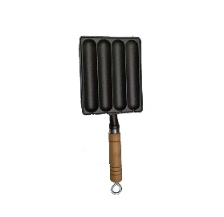
Z-029 | Tamago hotpot | 18.5cm*15.5*3.2cm | 1.05 | cast iron | Uncoated  Gas stove  induction cooker | 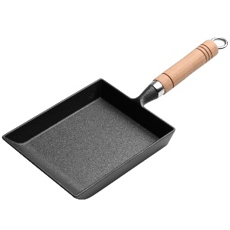

Xi'an Wanlai Trading Co., Ltd.
Serial Number | Product Name | Model (diameter/depth) cm | weight  KG | Material | Features | Product Image
Z-030 | Cast iron rectangular barbecue grill | 50cm*24cm*2cm | 4.3 | cast iron | Uncoated  Gas stove | 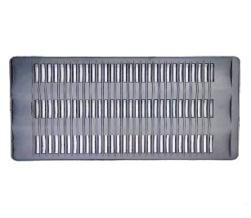
Z-031 | North Korean Yanbian Pot | 20cm in diameter * 10cm in depth  24cm in diameter * 12cm in depth | 3.3 | cast iron | Uncoated  Gas stove  induction cooker | 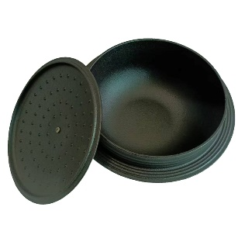
Z-031 | North Korean Yanbian Pot |  | 3.6 | cast iron | Uncoated  Gas stove  induction cooker
Z-032 | roasted sweet potato pot | 22cm in diameter * 8cm in height  Diameter 25cm * Height 8.5cm  Diameter 27cm * Height 9.5cm | 2.8 | cast iron | Uncoated  Gas stove | 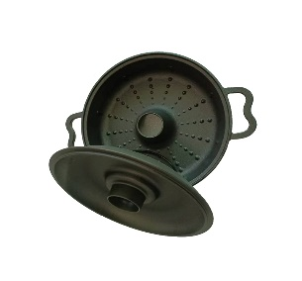
Z-032 | roasted sweet potato pot |  | 3.3 | cast iron | Uncoated  Gas stove
Z-032 | roasted sweet potato pot |  | 3.8 | cast iron | Uncoated  Gas stove
Z-033 | Old-fashioned three-legged griddle | Diameter 30cm * Height 3.8cm  Diameter 38cm * Height 3.8cm | 3.0 | cast iron | Uncoated  Gas stove | 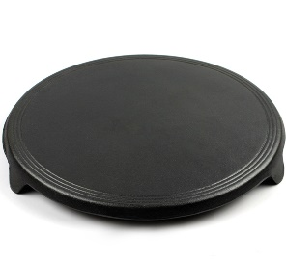
Z-033 | Old-fashioned three-legged griddle | Diameter 30cm * Height 3.8cm  Diameter 38cm * Height 3.8cm | 4.8 | cast iron | Uncoated  Gas stove

Xi'an Wanlai Trading Co., Ltd.
Serial Number | Product Name | Model (diameter/depth) cm | weight  KG | Material | Features | Product Image
Z-034 | Small oil pot | 10cm*2.5cm / 11cm*3cm  13cm*5cm/  15cm*5cm | 0.35 | cast iron | Uncoated  Gas stove  induction cooker | 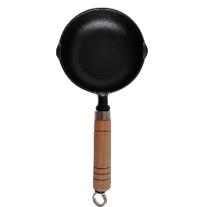
Z-034 | Small oil pot | 10cm*2.5cm / 11cm*3cm  13cm*5cm/  15cm*5cm | 0.4 | cast iron | Uncoated  Gas stove  induction cooker
Z-034 | Small oil pot | 10cm*2.5cm / 11cm*3cm  13cm*5cm/  15cm*5cm | 0.6 | cast iron | Uncoated  Gas stove  induction cooker
Z-034 | Small oil pot | 10cm*2.5cm / 11cm*3cm  13cm*5cm/  15cm*5cm | 0.75 | cast iron | Uncoated  Gas stove  induction cooker
Z-035 | Cast iron mini saucepan | Diameter 18.5cm * Height 9cm | 1.55 | cast iron | Uncoated  Gas stove  induction cooker | 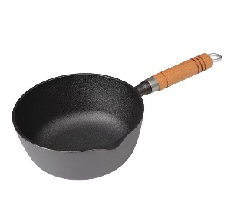
Z-036 | Wooden Handle Takoyaki  14 holes | 21cm*3cm  Wooden handle length 17cm | 1.3 | cast iron | Uncoated  Gas stove  induction cooker | 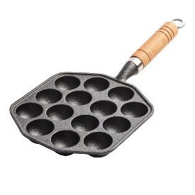
Z-037 | Takoyaki with two ears  15 holes | 23cm*21cm*3.5cm | 1.6 | cast iron | Uncoated  Gas stove  induction cooker | 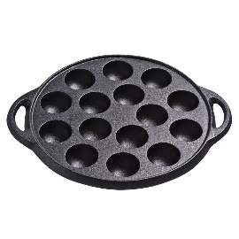
Z-038 | Double-eared square takoyaki  16 holes | 21cm*21cm*3.8cm | 1.7 | cast iron | Uncoated  Gas stove  induction cooker | 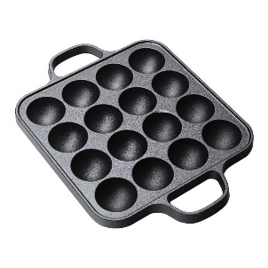

Xi'an Wanlai Trading Co., Ltd.
Serial Number | Product Name | Model (diameter/depth) cm | weight  KG | Material | Features | Product Image
Z-039 | Outdoor grill | 16cm*10cm/20cm*11cmc  23cm*11cm/28cm*13.5cm/  30.5cm*13.5cm | 2.0 | cast iron | Uncoated  charcoal  alcohol blocks | 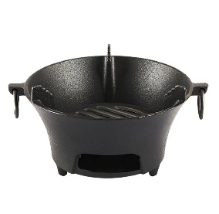
Z-039 | Outdoor grill | 16cm*10cm/20cm*11cmc  23cm*11cm/28cm*13.5cm/  30.5cm*13.5cm | 2.3 | cast iron | Uncoated  charcoal  alcohol blocks
Z-039 | Outdoor grill | 16cm*10cm/20cm*11cmc  23cm*11cm/28cm*13.5cm/  30.5cm*13.5cm | 2.6 | cast iron | Uncoated  charcoal  alcohol blocks
Z-039 | Outdoor grill | 16cm*10cm/20cm*11cmc  23cm*11cm/28cm*13.5cm/  30.5cm*13.5cm | 3.8 | cast iron | Uncoated  charcoal  alcohol blocks
Z-039 | Outdoor grill | 16cm*10cm/20cm*11cmc  23cm*11cm/28cm*13.5cm/  30.5cm*13.5cm | 4.3 | cast iron | Uncoated  charcoal  alcohol blocks
Z-040 | Old Beijing round-eared baking pan | 28CM*2CM  31CM*2CM | 2.3 | cast iron | Uncoated  Gas stove  induction cooker | 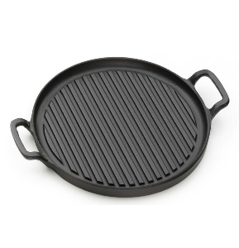
Z-040 | Old Beijing round-eared baking pan | 28CM*2CM  31CM*2CM | 2.8 | cast iron | Uncoated  Gas stove  induction cooker
Z-041 | Double-sided twill baking pan | 30CM*2.2CM  32CM*2.2CM | 3.0 | cast iron | Uncoated  Gas stove | 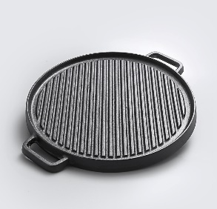
Z-041 | Double-sided twill baking pan | 30CM*2.2CM  32CM*2.2CM | 3.35 | cast iron | Uncoated  Gas stove
Z-042 | Double-sided baking pan | 36CM*3CM | 4.3 | cast iron | Uncoated  Gas stove | 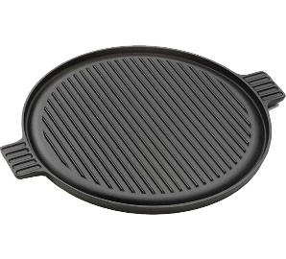
Z-043 | Double-eared steak pan | 31CM*3.5CM  Total length 38CM | 3.2 | cast iron | Uncoated  Gas stove  induction cooker | 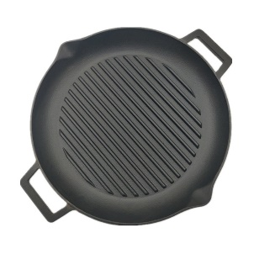
Xi'an Wanlai Trading Co., Ltd.
Serial Number | Product Name | Model (diameter/depth) cm | weight  KG | Material | Features | Product Image
Z-044 | T201T202T203  Double-sided baking pan | 30cm*20cm*1.2cm  37cm*23cm*1.2cm  42cm*23cm*1.2cm | 2.6 | cast iron | Uncoated  Gas stove | 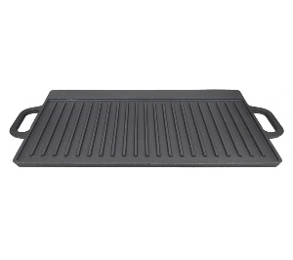
Z-044 | T201T202T203  Double-sided baking pan | 30cm*20cm*1.2cm  37cm*23cm*1.2cm  42cm*23cm*1.2cm | 3.3 | cast iron | Uncoated  Gas stove
Z-044 | T201T202T203  Double-sided baking pan | 30cm*20cm*1.2cm  37cm*23cm*1.2cm  42cm*23cm*1.2cm | 3.8 | cast iron | Uncoated  Gas stove
Z-045 | Double-eared baking pan  Grilled fish plate | 39CM*29.5CM*3.6CM | 5.3 | cast iron | Uncoated  Gas stove  induction cooker | 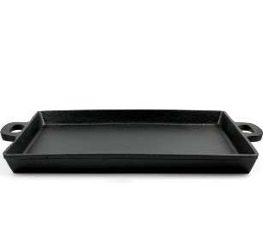
Z-046 | Spring-handled baking pan |  |  | cast iron | Uncoated  Gas stove | 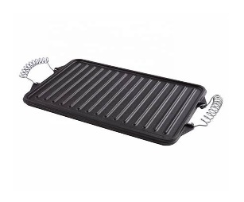
Z-047 | P21 Striped Grill  - Horizontal stripes  - diagonal stripes | (1) 45.5cm*25.5cm*  (2) 45.5cm * 25.5cm | 4.2 | cast iron | Uncoated  Gas stove | 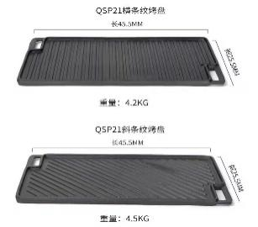
Z-047 | P21 Striped Grill  - Horizontal stripes  - diagonal stripes | (1) 45.5cm*25.5cm*  (2) 45.5cm * 25.5cm | 4.5 | cast iron | Uncoated  Gas stove
Z-048 | diagonal of rectangle  Double-sided baking pan | 43CM*24CM*1.3CM | 4.0 | cast iron | Uncoated  Gas stove | 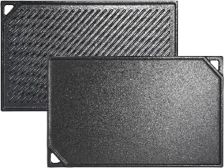
Xi'an Wanlai Trading Co., Ltd.
Serial Number | Product Name | Model (diameter/depth) cm | weight  KG | Material | Features | Product Image
Z-049 | Double-eared solid baking pan |  |  | cast iron | Uncoated  Gas stove  induction cooker | 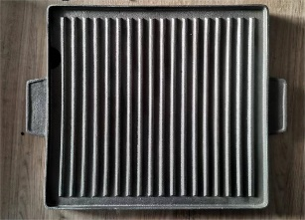
Z-050 | rectangular curved handle  baking pan |  |  | cast iron | Uncoated  Gas stove | 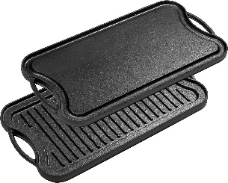
Z-051 | Barbecue grill  Circular stripes | 25cm*1cm / 30cm*1cm  38cm*1cm  46cm*1cm | 1.6 | cast iron | Uncoated  Gas stove  induction cooker | 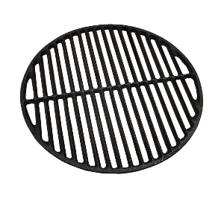
Z-051 | Barbecue grill  Circular stripes | 25cm*1cm / 30cm*1cm  38cm*1cm  46cm*1cm | 2.5 | cast iron | Uncoated  Gas stove  induction cooker
Z-051 | Barbecue grill  Circular stripes | 25cm*1cm / 30cm*1cm  38cm*1cm  46cm*1cm | 3.8 | cast iron | Uncoated  Gas stove  induction cooker
Z-051 | Barbecue grill  Circular stripes | 25cm*1cm / 30cm*1cm  38cm*1cm  46cm*1cm | 5.2 | cast iron | Uncoated  Gas stove  induction cooker
Z-052 | Circular square  Barbecue grill  Barbecue net | 29.5CM*1.1CM  46CM*1.1CM | 1.6 | cast iron | Uncoated  Gas stove | 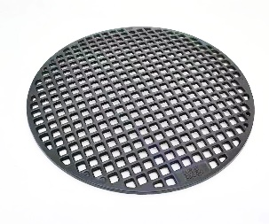
Z-052 | Circular square  Barbecue grill  Barbecue net | 29.5CM*1.1CM  46CM*1.1CM | 5.6 | cast iron | Uncoated  Gas stove
Z-053 | Circular square grid  Barbecue grill | 30CM*1CM  35CM*1CM | 2.2 | cast iron | Uncoated  Gas stove | 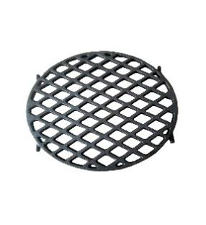
Z-053 | Circular square grid  Barbecue grill | 30CM*1CM  35CM*1CM | 2.6 | cast iron | Uncoated  Gas stove
Xi'an Wanlai Trading Co., Ltd.
Serial Number | Product Name | Model (diameter/depth) cm | weight  KG | Material | Features | Product Image
Z-054 | Square hole  Round BBQ Net | 29.5CM*1  33CM*1 | 1.7 | cast iron | Uncoated  Gas stove | 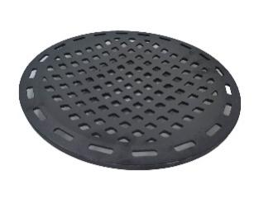
Z-054 | Square hole  Round BBQ Net | 29.5CM*1  33CM*1 | 1.9 | cast iron | Uncoated  Gas stove
Z-055 | Sunflower Cast Iron Baking Pan | 29.5CM*1CM  33CM*1CM | 2.1 | cast iron | Uncoated  Gas stove | 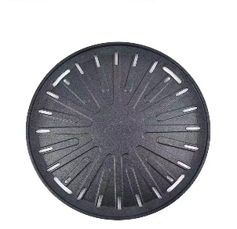
Z-055 | Sunflower Cast Iron Baking Pan | 29.5CM*1CM  33CM*1CM | 2.3 | cast iron | Uncoated  Gas stove
Z-056 | Strip-shaped perforated baking pan | 29.5CM*1CM  33CM*1CM | 1.8 | cast iron | Uncoated  Gas stove | 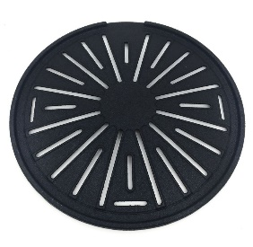
Z-056 | Strip-shaped perforated baking pan | 29.5CM*1CM  33CM*1CM | 2.0 | cast iron | Uncoated  Gas stove
Z-057 | Bar cast iron baking pan | 29.5CM*1CM  33CM*1CM | 1.4 | cast iron | Uncoated  Gas stove | 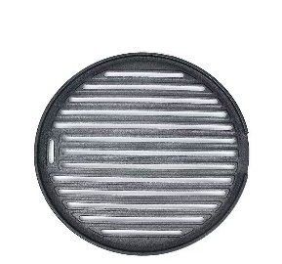
Z-057 | Bar cast iron baking pan | 29.5CM*1CM  33CM*1CM | 1.6 | cast iron | Uncoated  Gas stove
Z-058 | Korean-style smooth cast iron  baking pan | 29.5CM*1CM  33CM*1CM | 1.8 | cast iron | Uncoated  Gas stove | 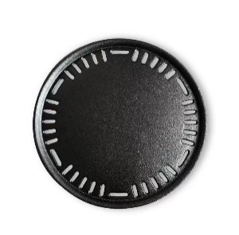
Z-058 | Korean-style smooth cast iron  baking pan | 29.5CM*1CM  33CM*1CM | 2.0 | cast iron | Uncoated  Gas stove
Xi'an Wanlai Trading Co., Ltd.
Serial Number | Product Name | Model (diameter/depth) cm | weight  KG | Material | Features | Product Image
Z-059 | Thick cast iron baking pan | Outer diameter 43cm * Inner diameter 14cm  Outer diameter 56CM * Inner diameter 26CM | 4.8 | cast iron | Uncoated  Gas stove | 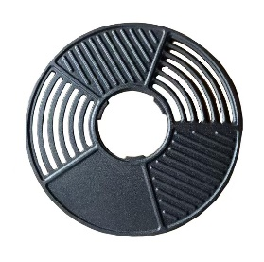
Z-059 | Thick cast iron baking pan |  | 7.5 | cast iron | Uncoated  Gas stove
Z-060 | Iron Hat Baking Pan  Hollow out  Little Iron Hat | 32.5cm*3cm  20CM*2CM | 2.4 | cast iron | Uncoated  Gas stove | 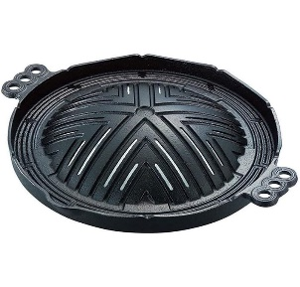
Z-060 | Iron Hat Baking Pan  Hollow out  Little Iron Hat | 32.5cm*3cm  20CM*2CM | 0.9 | cast iron | Uncoated  Gas stove
Z-061 | South African pot - cauldron | 1/4 # 1 /2# 3/4# 1#  2 # 3 # 4# 6# 8#  10 # 14 # 20 # 25 # |  | cast iron | Uncoated  Gas stove  induction cooker | 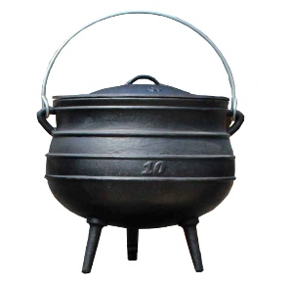
Z-062 | Grill and hot pot combo  High and low pots | Mouth diameter 24CM * height 8CM  13cm hot pot opening  11cm opening of baking pan | 2.7 | cast iron | Uncoated  Gas stove  induction cooker | 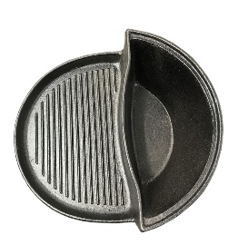
Z-063 | Enameled Tai Chi  High and low pots | 24cm in diameter  Height 8CM | 2.8 | cast iron | Uncoated  Gas stove  induction cooker | 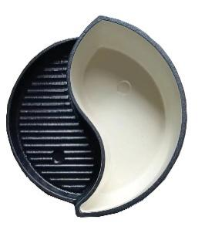
Xi'an Wanlai Trading Co., Ltd.
Serial Number | Product Name | Model (diameter/depth) cm | weight  KG | Material | Features | Product Image
Z-064 | Cast iron  Grilling pan | Outer diameter 35CM * Inner diameter 20CM  Outer diameter 45CM * Inner diameter 20CM | 4.5 | cast iron | Uncoated  Gas stove | 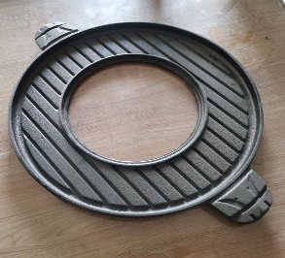
Z-064 | Cast iron  Grilling pan |  | 5.0 | cast iron | Uncoated  Gas stove
Z-065 | Large and medium hole baking pan | 33CM*14CM  52CM*29.5CM | 3.5 | cast iron | Uncoated  Gas stove | 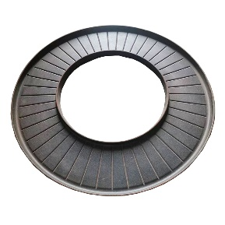
Z-065 | Large and medium hole baking pan | 33CM*14CM  52CM*29.5CM | 10 | cast iron | Uncoated  Gas stove
Z-066 | Square double-sided baking pan | 32CM*32CM*2.2CM  42CM*42CM*2.2CM | 5.5 | cast iron | Uncoated  Gas stove | 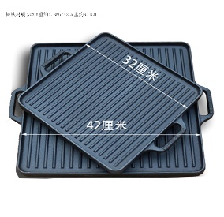
Z-066 | Square double-sided baking pan | 32CM*32CM*2.2CM  42CM*42CM*2.2CM | 8.9 | cast iron | Uncoated  Gas stove
Z-067 | Square double ears  Striped shallow dish | 28CM*28CM*2CM | 2.4 | cast iron | Uncoated  Gas stove  induction cooker | 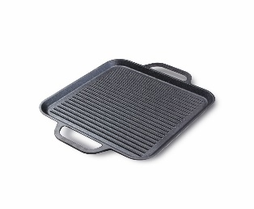
Z-068 | Dutch pan  hanging pot | 20cm (liter) 25cm (4 liters)  31cm (8 liters)  37cm (12 liters) | 2.8 | cast iron | Uncoated  Gas stove  induction cooker | 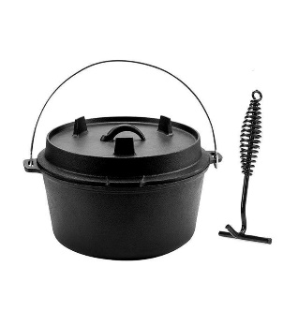
Z-068 | Dutch pan  hanging pot |  | 3.8 | cast iron | Uncoated  Gas stove  induction cooker
Z-068 | Dutch pan  hanging pot |  | 5.6 | cast iron | Uncoated  Gas stove  induction cooker
Z-068 | Dutch pan  hanging pot |  | 8.4 | cast iron | Uncoated  Gas stove  induction cooker
Xi'an Wanlai Trading Co., Ltd.
Serial Number | Product Name | Model (diameter/depth) cm | weight  KG | Material | Features | Product Image
Z-069 | Feng-shaped oval plate | 23CM*14.5CM*2CM  25CM*16CM*2CM  28CM*17CM*2.5CM | 0.7 | cast iron | Uncoated  Gas stove  induction cooker | 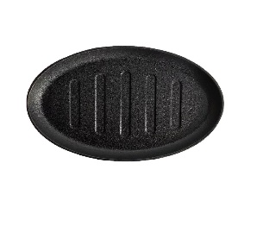
Z-069 | Feng-shaped oval plate | 23CM*14.5CM*2CM  25CM*16CM*2CM  28CM*17CM*2.5CM | 0.9 | cast iron | Uncoated  Gas stove  induction cooker
Z-069 | Feng-shaped oval plate | 23CM*14.5CM*2CM  25CM*16CM*2CM  28CM*17CM*2.5CM | 1.2 | cast iron | Uncoated  Gas stove  induction cooker
Z-070 | frying pan with secondary handle | 10-inch (25cm x 5.3cm)  12-inch 29cm x 6cm | 2.2 | cast iron | Uncoated  Gas stove  induction cooker | 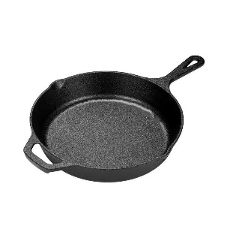
Z-070 | frying pan with secondary handle | 10-inch (25cm x 5.3cm)  12-inch 29cm x 6cm | 3.2 | cast iron | Uncoated  Gas stove  induction cooker
Z-071 | Folding Handle Steak Pot  rectangle | 30CM*20CM  Handle length 19CM | 2.0 | cast iron | Uncoated  Gas stove  induction cooker | 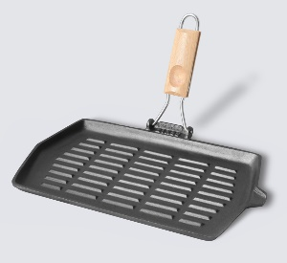
Z-072 | Folding Handle Steak Pot  square | 28CM*28CM*2CM  Handle length 18CM | 2.5 | cast iron | Uncoated  Gas stove  induction cooker | 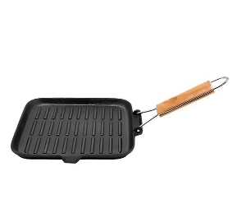
Z-073 | waffle iron | 20cm in diameter  The total length of the pot is 34 cm. | 3.5 | cast iron | Uncoated  Gas stove  induction cooker | 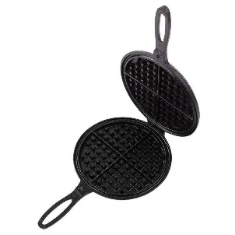
Xi'an Wanlai Trading Co., Ltd.
Serial Number | Product Name | Model (diameter/depth) cm | weight  KG | Material | Features | Product Image
Z-074 | Round meat press | 17.5 cm in diameter  Height 6.8CM | 0.9 | cast iron | Uncoated | 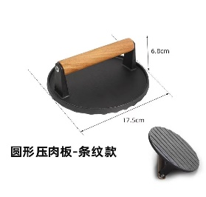
Z-075 | rectangular meat press board | 20CM*10CM  Height 6.8CM | 1.1 | cast iron | Uncoated | 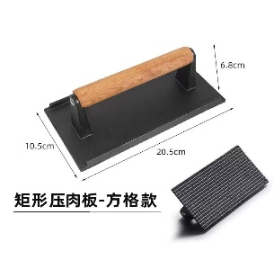
Z-076 | Seven-hole pastry mold | 32CM*28CM*3CM | 2.0 | cast iron | Uncoated  Gas stove  induction cooker | 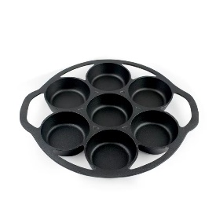
Z-077 | New seven-hole egg mold | Diameter 27CM * 2.5CM  Total length 31.5CM  Single hole diameter 8CM | 2.2 | cast iron | Uncoated  Gas stove  induction cooker | 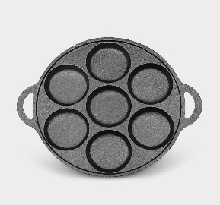
Z-078 | Homemade hamburger pan  Wooden Handle Five-Hole Egg Fryer | 27CM*2.5CM  The total length of the handle is 18.5 cm. | 1.8 | cast iron | Uncoated  Gas stove  induction cooker | 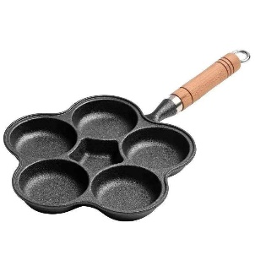
Xi'an Wanlai Trading Co., Ltd.
Serial Number | Product Name | Model (diameter/depth) cm | weight  KG | Material | Features | Product Image
Z-079 | Double-eared oval pot | 16CM*9.5CM*3CM  18CM*12CM*3CM  22CM*16CM*4CM  24CM*17CM*4.5CM  Ears 4cm long | 0.6 | cast iron | Uncoated  Gas stove  induction cooker | 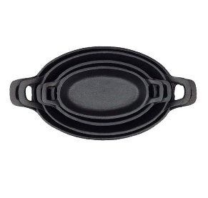
Z-079 | Double-eared oval pot |  | 0.8 | cast iron | Uncoated  Gas stove  induction cooker
Z-079 | Double-eared oval pot |  | 1.3 | cast iron | Uncoated  Gas stove  induction cooker
Z-079 | Double-eared oval pot |  | 1.6 | cast iron | Uncoated  Gas stove  induction cooker
Z-80 | rectangular bread box | 22CM*12CM*12CM | 4.7 | cast iron | Uncoated  Gas stove  induction cooker | 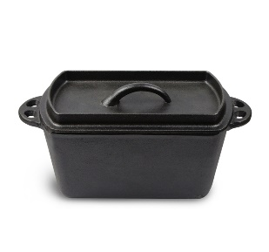
Z-081 | Cast iron bread pan | Inner dimensions: 22cm x 11cm x 11cm  External dimensions  27cm x 16cm x 12cm | 4.9 | cast iron | Uncoated  Gas stove  induction cooker | 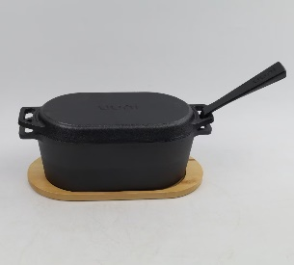
Z-082 | Yuan Yang Hot Pot | 30cm in diameter * 10cm  33cm in diameter * 10cm | 6.8 | cast iron | Uncoated  Gas stove  induction cooker | 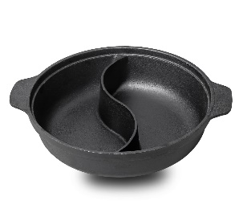
Z-082 | Yuan Yang Hot Pot | 30cm in diameter * 10cm  33cm in diameter * 10cm | 8.5 | cast iron | Uncoated  Gas stove  induction cooker
Z-083 | Single-sided box bread tongs | 10.5CM*10.5CM*4.5CM  14CM*14CM*4.5CM  The pole is 20cm/25cm/30cm long. | 2.5 | cast iron | Uncoated  Gas stove  induction cooker | 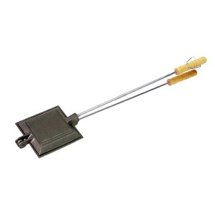
Z-083 | Single-sided box bread tongs |  | 3.5 | cast iron | Uncoated  Gas stove  induction cooker
Xi'an Wanlai Trading Co., Ltd.
Serial Number | Product Name | Model (diameter/depth) cm | weight  KG | Material | Features | Product Image
Z-084 | Cast iron stewed fish baking pan | 33CM*23CM*6.0CM  38CM*27CM*8.5CM | 3.5 | cast iron | Uncoated  Gas stove  induction cooker | 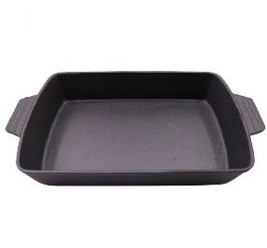
Z-084 | Cast iron stewed fish baking pan | 33CM*23CM*6.0CM  38CM*27CM*8.5CM | 6.3 | cast iron | Uncoated  Gas stove  induction cooker
Z-085 | Barbecue grill | 54CM*34CM*1.2CM |  | cast iron | Uncoated  Gas stove | 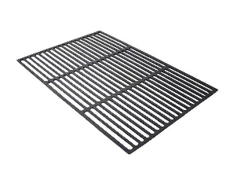
Z-085 | Barbecue grill | 54CM*34CM*1.2CM | 2.8 | cast iron | Uncoated  Gas stove
Z-086 | Cast iron diagonal striped baking pan | 16CM*37CM*3CM | 1.5 | cast iron | Uncoated  Gas stove  induction cooker | 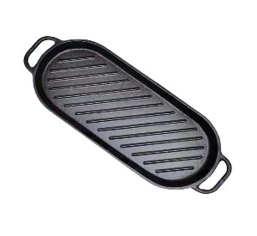
Z-087 | Cast iron single handle  oval pot | 25CM*18.5CM*2CM  The handle is 13.5 cm long. | 1.4 | cast iron | Uncoated  Gas stove  induction cooker | 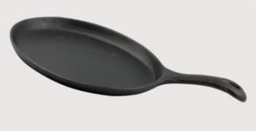
Z-088 | Cast iron baking plate | 37CM*11CM*1CM | 1.6 | cast iron | Uncoated  Gas stove  induction cooker | 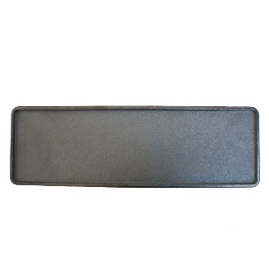
Xi'an Wanlai Trading Co., Ltd.
Serial Number | Product Name | Model (diameter/depth) cm | weight  KG | Material | Features | Product Image
Z-089 | Wide-striped gardenia  Single-sided baking pan | Diameter 31CM * 1.5CM | 2.5 | cast iron | Uncoated  Gas stove  induction cooker | 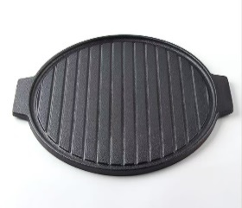
Z-090 | Wide stripes with oil nozzle  Single-sided baking pan | Diameter 31CM * 1.5CM | 2.6 | cast iron | Uncoated  Gas stove  induction cooker | 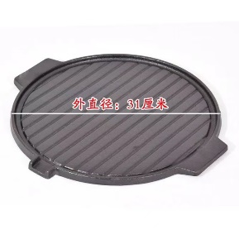
Z-091 | Cast iron oyster baking pan  12-hole baking pan |  |  | cast iron | Uncoated  Gas stove  induction cooker
Z-092 | Cast iron patty press | 15CMC  20CM  25CM | 2.0 | cast iron | Uncoated | 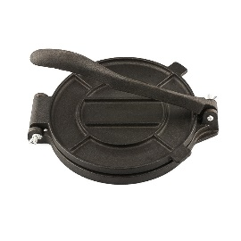
Z-092 | Cast iron patty press | 15CMC  20CM  25CM | 2.9 | cast iron | Uncoated
Z-092 | Cast iron patty press | 15CMC  20CM  25CM | 4.9 | cast iron | Uncoated
Z-093 | Cannonball pot African stew | 4L 24.5CM *16CM  7L 27.5CM *22CM  10L 30.5CM *22CM |  | cast iron | Uncoated  Open flame | 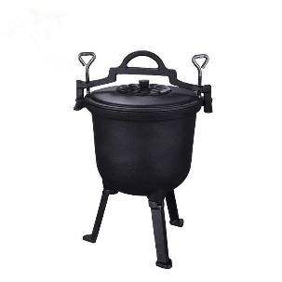
Xi'an Wanlai Trading Co., Ltd.
Serial Number | Product Name | Model (diameter/depth) cm | weight  KG | Material | Features | Product Image
Z-094 | small fork |  | 0.3 | cast iron | Uncoated | 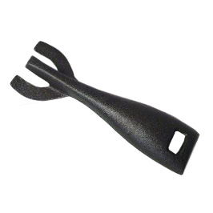
Z-095 | Four-claw windproof cover |  | 1.2 | cast iron | Uncoated  Gas stove | 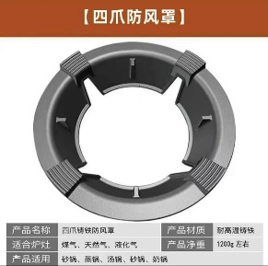
Z-096 | Gas stove support | Outer diameter 17.8CM  Inner diameter 8.5CM  Thickness 0.8CM | 0.35 | cast iron | Uncoated  Gas stove | 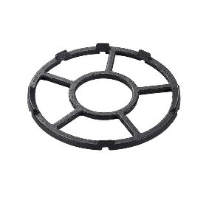
Z-097 | Pot holder | Diameter 21CM * Thickness 0.4CM | 0.5 | cast iron | Uncoated | 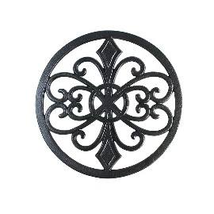
Z-098 | Gas stove support | 17.8CM*8.5CM*0.8CM | 0.4 | cast iron | Uncoated  Gas stove | 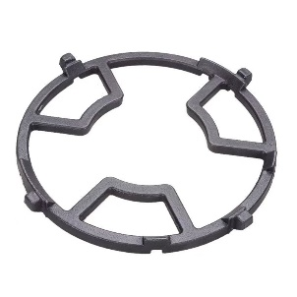
Xi'an Wanlai Trading Co., Ltd.
Serial Number | Product Name | Model (diameter/depth) cm | weight  KG | Material | Features | Product Image
Z-099 | wooden support  Customized products | 21CM*12CM*2CM  23.5CM*13.5CM*2CM  26CM*15.5CM*2CM | 0.3 | oak  birch |  | 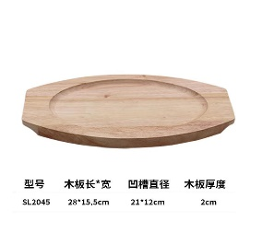
Z-100 | Cedar wood pot lid  Customized products | Diameter: 20CM/21CM/22CM  23CM/24CM/25CM/26CM  27CM/28CM/29CM/30CM  31CM/32CM/33CM/34CM/35CM/36CM/37CM/38CM/  39CM/40CM/41CM/42CM/  43CM/44CM/45CM/46CM | 0.25 | Chinese fir | carbonization  deal with | 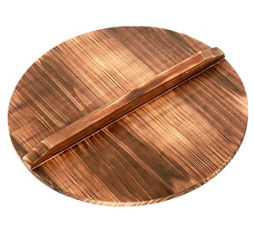
Z-101 | Wooden shovel | Total length 25CM  6cm wide shovel | 0 | Bamboo and wood |  | 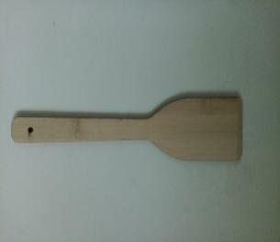
Z-102 | Korean- style steak hot pot | 22CM  24CM  The spoon handle is 16 cm long. | 1.3 | cast iron | Uncoated  Gas stove  induction cooker | 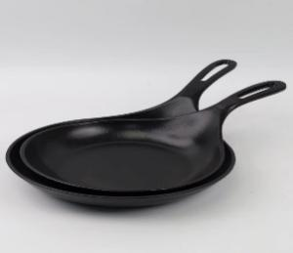
Z-102 | Korean- style steak hot pot | 22CM  24CM  The spoon handle is 16 cm long. | 1.6 | cast iron | Uncoated  Gas stove  induction cooker
Z-103 | Oyster baking pan |  |  | cast iron | Uncoated  Gas stove | 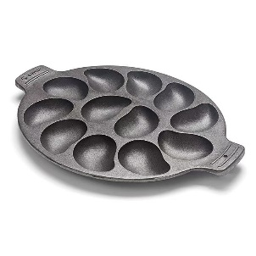
Xi'an Wanlai Trading Co., Ltd.

